Tanvir Randhawa
z5481573
ACTL3162 General Insurance Techniques
Task 1

In this report, we aim to provide a detailed analysis of loss severity data by first fitting a suitable distribution through the maximum likelihood estimation (MLE) method, experimenting with Pareto, log normal, exponential and gamma models, of which the gamma distribution was found to be the strongest. We also experimented with censored data to model the changes by fitting QQ plots.

1.1 Fitting the Candidate Models
We utilised MLE analysis to determine the parameters for our candidate models for the claim sizes. To do this, we used R software, where We first found the joint likelihood of each candidate function's probability density function (PDF), which is determined by multiplying the likelihoods for each observed data point. The PDF of each candidate model is listed in Appendix 8. We then found the log-likelihood, which is found by taking the logarithm of the joint likelihood. We utilised the ‘optimise’ function in R to simplify the following process, the concept behind it is to differentiate the equations and then equate them to 0, rearranging for each of the parameters, which is known as the estimator equation. We then utilised R to input the relevant values for each estimator to determine the parameter estimates listed in the table below.

Model | Parameter Estimate(s)
Log Normal | $$\hat{μ}=8.2237 \hat{σ}= 1.4181$$
Gamma | $$\hat{α}=0.8766 \hat{λ}= 0.00012046$$
Exponential | $$\hat{λ}= 0.00013737$$
Pareto | $$\hat{α}=0.122836 \hat{λ}= 1.086260$$
Table 1 – Parameter Estimates with complete data

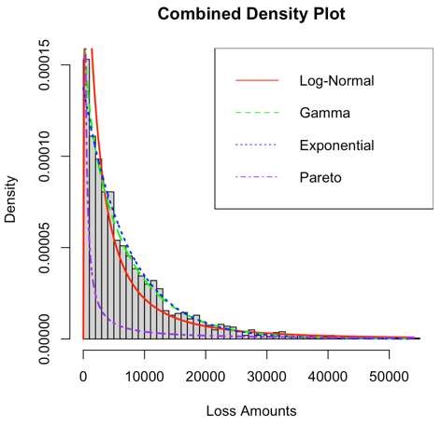
For the Log-Normal distribution, there are two parameters to estimate: the mean and standard deviation. The parameters estimated highlight that there is a broad range of values, which we understand through the higher standard deviation, it is also centred at a relatively low value, suggesting a positive skewness, which is expected in insurance modelling. The exponential distribution has a single parameter $λ$ that represents the rate and is the inverse of the mean when working with complete data. The MLE estimate we found aligns well with our uncensored data's large mean claim sizes. Hence, the rate parameter is fairly low. For Gamma Distribution, the estimated relatively low shape parameter indicates a right-skewed distribution, which implies that smaller claims are more probable. A comparatively high shape parameter for the Pareto distribution indicates that smaller claims contribute more significantly to the total claim value, suggesting a more concentrated claim distribution where fewer larger claims dominate the total value.

1.2 Visualisation of the Model Fitting

The combined density plot in Figure 1 displays how each of the PDFs of the candidate distributions fit in reference to the claim distributions, it is evident that Pareto will be a weaker fit since it does not align well with the densities of the histogram bars. Contrarily, both gamma and exponential seem to be a decent fit just based on this.

This fit can be better displayed by the QQ and PP plots in Figure 2, which show how accurate it is compared to an ideal fit of the candidate distributions, the more in line with the diagonal the fitted model is, the better the fit is.
Figure 1
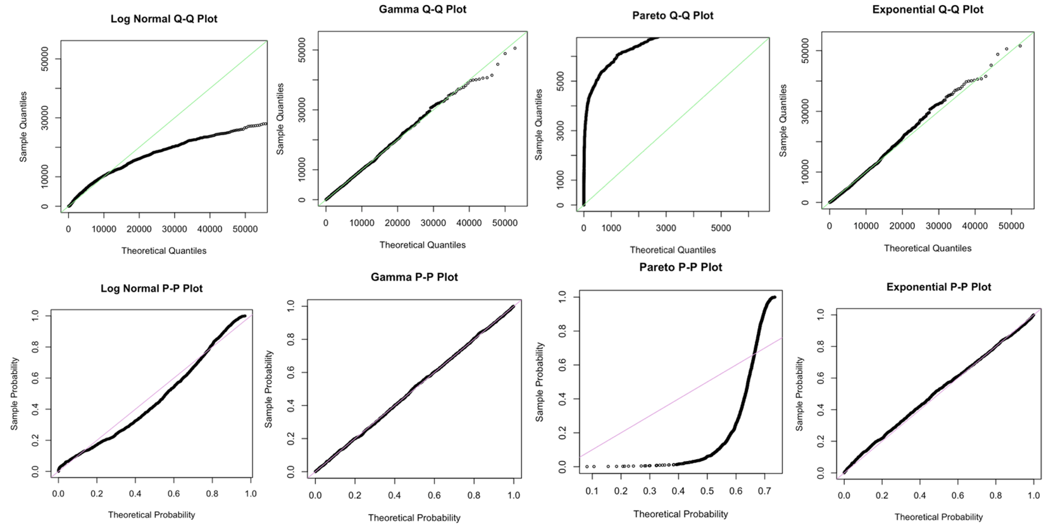
Figure 2

The Q-Q and P-P plots reveal notable discrepancies between the fitted and theoretical distributions for some candidate models, suggesting that the fitted model deviates significantly from the expected theoretical pattern. These deviations indicate some of the suggested models may be more appropriate to better capture the underlying data.
From the graphs, it's clear that both the Pareto and Log-Normal distributions are unsuitable, as they show substantial deviations across the entire range of the data. This makes sense since the Pareto distribution is typically more effective in scenarios where a small number of claims dominate in size, meaning there are heavy tails, which is not the case here since there are relatively few large claims. Although the distribution is positively skewed, there are a significant number of large claims that have a decent influence on the overall model. Whilst there is positive skewness, it is not extreme enough to align with the requirements of a Log-Normal distribution, making it an inappropriate model as well. The above plots are also very useful in displaying that both the Exponential and Gamma models are competent in fitting the distributions as the theoretical and fitted values are essentially identically, and so are the theoretical and sample probability in the PP plots. It is slightly inaccurate at the positive tail where there is deviation, perhaps due to the heavy tail resulting from the fairly high quantity of large claims, as seen in Appendix 6. Both models seem to be equally competent with these plots, making it difficult to choose between the two models without further testing.

1.3 Hypothesis Testing
We utilised hypothesis testing with the Kolmogorov-Smirnov (KS) and Anderson-Darling (AD) tests, which each served their unique purpose, the KS tests are more well-rounded and examine the overall fit of the model, whereas AD tests are more useful to investigate the strength of the fit towards the tails since the calculations place a heavier emphasis on the tails. We first fitted each model with the complete data to evaluate the models and computed the corresponding test statistics for both the AD and KS tests. The logic behind the test statistics is further explained in Appendix 1, but generally, we compared the differences in the fitted and empirical models.

The null hypothesis for the AD test states that the sample data comes from the specified distribution, while the alternative hypothesis posits that it does not. For the KS test, the null hypothesis asserts that the two distributions are the same, whereas the alternative suggests they are different this is further explained in Appendix 2, We calculated each model's AD and KS test statistics, comparing them against the critical values determined with a significance level of 0.05. The decision rule established for this analysis indicated that if the p-value is less than 0.05, we reject the null hypothesis, hence the proposed model is not suitable; if it does exceed the critical value, we will fail to reject the null hypothesis, meaning the candidate model is a potentially suitable fit. The breakdown of the hypothesis test can be seen below.

Model | AD Test critical value | AD Test P Value | Reject or fail to reject null? | KS Test critical value | KS Test P Value | Reject or fail to reject null?
Log-Normal | 28.506 | 3e-07 | Reject | 0.080226 | 1.319e-11 | Reject
Gamma | 0.229 | 0.9804 | Fail to reject | 0.012619 | 0.9077 | Fail to reject
Exponential | 4.831 | 0.003454 | Reject | 0.03148 | 0.03797 | Reject
Gamma | 640.19 | 3e-07 | Reject | 0.44744 | 2.2e-16 | Reject
Table 2 – AD and KS Tests with each Candidate model

For all candidate models except Gamma, the tests suggest that the observed data does not follow the specified distribution due to the very low p values, which provides strong evidence to reject the null which states that the candidate model would be a good fit. Gamma is the only suitable model since it has the highest p-value for both the AD and KS tests hence, we fail to reject the null since there is not enough evidence to say that the data deviates significantly from the specified theoretical distribution, being Gamma. The higher P value in the AD test portrays that the Gamma model fits the tails quite well, but the high KS test value also supports the strong overall fit of the model.

1.4 AIC and BIC Decision Criteria
We can further support our reasoning for choosing the Gamma model above with the AIC and BIC values seen in Table 3 as the final supporting method. These are a standard measure for determining which model is best fitting depending on when the AIC and BIC are minimised. According to all values seen in the table, the lowest values are seen in the Gamma model, which is slightly lower than that of the exponential model, emphasising how both are suitable, given the nature of the problem as it is in an insurance contract. Given the hypothesis testing results, it is best to opt for the Gamma model.

Model | AIC | BIC
Log-Normal | 39972.37 | 39983.58
Gamma | 39573.26 | 39578.86
Exponential | 39551.74 | 39562.94
Pareto | 45286.35 | 45297.55
Table 3 – AIC and BIC values for fitted models

The choice of the Gamma model is not simply due to its numerical values; it is also a very common insurance model since it is flexible and can model a wide range of data due to its flexible shape and scale parameters. This flexibility allows it to capture various claim size distributions, from light-tailed to heavy-tailed, the latter of which is the case here. Insurance claims usually exhibit positive skewness, as is the case here, where most claims are small, but a few can be very large. The Gamma distribution inherently accommodates this positive skewness, making it suitable for modelling claims where high severity can have a significant impact on overall losses. It is also memoryless, which is a very important factor in insurance; this property arises since the gamma distribution is the sum of several independent exponentially distributed random variables. Gamma distribution will also simplify calculations as it allows for straightforward calculations of risk measures such as Value at Risk and the tail Value at Risk, which are essential for assessing the financial stability of insurance companies.

1.5 Censored Data
In insurance, data adjustments are prevalent, in this case, we have the right censorship of data through the policy limit of $10000. In this scenario where all claims of size greater than $10000 are recorded as $10000, this means that as the insurer, we only pay out $10000 even if the claim size is larger. We should analyse what candidate model fits best with this scenario using similar methods as previously. Although the Gamma model was found to be the best in the complete data case, that will not necessarily be the case here since we have a heavier tail. We fit both the Pareto and exponential model using a similar method as for part 1.1, except this time, we included the right censored data using if statements in R to convert all claims above $10000 to $10000. For the previous uncensored data, we formed the likelihood function using the PDF of the distributions, however, for censored data, we adjusted the likelihood function to account for the survival function, which is detailed in the appendix alongside the likelihood functions. We include the survival functions to account for the probability of being greater than the policy limit without assuming exact claim sizes. We computed this numerically for the Pareto model (refer to Appendix 4), using R to find the estimates, substituting the relevant values and using R for the exponential model. We found the following parameter estimates.

Model | Parameter Estimate(s)
Exponential | $\hat{λ}=0.00014188$0.
Pareto | $$\hat{α}= 0.092276 \hat{λ}=1.08626$$
Table 4 – Parameters for fitted models with censored data

These estimates align with our expectations since the exponential model has a higher rate parameter estimate than that of the prior estimate. This is because the maximum payout is now only $10000. Hence, the mean is lower, thereby, the rate is higher. Since the distribution of claims is now slightly more consistent, as shown in Appendix 6, the positive skewness is still evident, but there is also a notable peak at $10,000, indicating a higher frequency of claims at that amount rather than a long tail. The shape parameter is lower than it was with uncensored data, showing that a larger proportion of the data is in the tail, leading to relatively more extreme values. The $\hat{λ}$ is the same in both the censored and uncensored models as it represents the minimum claim size, which is equal for both since the data is right censored. Hence, small claim sizes are not adjusted. The lower alpha value suggests that large claim sizes are more probable than they were pre-censoring. Although the Pareto distribution was not suitable before, it may now be a more suitable model since there is a high concentration around the $10000 mark.

To visualise this, we again utilised QQ plots; these plots were generated through the assistance of R with the ggplot package. Similar to those of section 1.2, we fit the theoretical vs. the fitted, where the closer the fit is to the linear reference line, the better the fit. Whilst the direct QQ plots are seen in Appendix 5, we adjusted the x-axis, restricting it to 20000, so that a clearer trend could be observed in Figure 3.
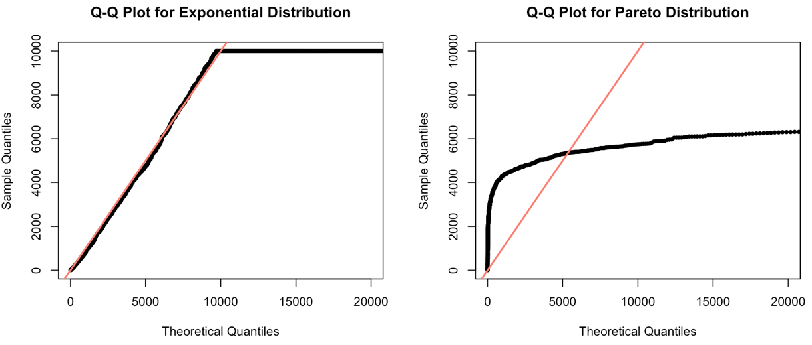
Figure 3

1.6 Comparison of Censored Data Models Visually
These Q-Q plots indicate that, with data censoring, the exponential model does not fit the claims of size $10,000 well, given the large quantity at this level. This is seen through the heavy tail represented by the horizontal line. However, the earlier quantiles align closely with the empirical values, consistent with the findings in Section 1.2. This alignment suggests a good fit for smaller claims. This lack of consistently strong fit poses limitations to this model since there are a concerning amount of claims of size $10000 or greater. This limits the effectiveness of the model. However, it can be improved, for example, through the increase of the policy limit. When the policy limit was increased to $15000 to examine the improvement, there was a less dramatic peak towards the tails, as can be seen in Appendix 6, insurers should further explore the possibilities surrounding this.

Although the exponential model is simpler and may be preferable for analysing frequent, smaller claims, its inability to account for the influence of rare but severe claims can lead to misrepresentation. In contrast, the heavy-tailed nature of the Pareto distribution allows for more accurate modelling of such extreme events, even when censoring mitigates the impact of larger claims. It is difficult to determine which of the two models is superior since we have not conducted hypothesis tests, which is a limitation.

Ultimately, insurers can greatly benefit from this historical data provided to us and use it to our advantage to provide better insurance policies for all policyholders. Insurers should consider increasing the policy limit since there are far too many claims falling into that category, which is making it difficult to fit a model well, which diminishes the potential of the model since it is not as accurate as can be. Insurers can conduct a similar analysis as is done in this report to find what model fits their historical loss data better, although the gamma model is competent in this report, it is not guaranteed with any data set.
Appendix

Appendix 1 – AD and KS Tests
KS Test
$$D_{n}=\sup_{y}|\hat{{ G}_{n}}\left(y\right)- \hat{G_{0}}\left(y\right) |$$

AD Test
$$A_{n}=n \int{\frac{{\hat{{( G}_{n}}\left(y\right)- G_{0}\left(y\right))}^{2}}{G_{0}\left(y\right)\left(1-G_{0 }\left(y\right)\right)}dG_{0}\left(y\right)}$$
Since fitted model $G_{0}(y)$ is on the denominator and with very large or small y values, the function is more affected, hence this test is more useful in determining the strength of the model in fitting tail values.

Appendix 2 – Hypothesis Testing in AD and KS Tests
KS Test Interpretation:
H0 = Null hypothesis: The data comes from the specified distribution.
H1 = Alternative hypothesis: The data does not come from the specified distribution.

- If the p-value ≤ α (e.g., 0.05): Reject the null hypothesis.
  - This means the data provides strong evidence that the observed distribution is different from the specified theoretical distribution.
- If the p-value > α (e.g., 0.05): Fail to reject the null hypothesis
  - This suggests there isn't enough evidence to say the data differs from the specified distribution.

AD Test Interpretation:
H0 = Null Hypothesis: The data follows the specified distribution.
H1 = Alternative Hypothesis: The data does not follow the specified distribution.

- p-value > 0.05: If the p-value is greater than 0.05, we fail to reject the null hypothesis, meaning that there is no strong evidence to suggest the data does not follow the Pareto distribution.
- p-value ≤ 0.05: If the p-value is 0.05 or less, you would reject the null hypothesis, meaning the specified distribution does not fit the data well.

Appendix 3 – Steps for MLE Estimation of the Parameters
What are the likelihood functions
Step 1. Find the joint probability (or probability density) of given data in reference to the suggested distribution. This all multiplied together becomes the likelihood function.
Step 2. Since products are difficult to maximize directly, take the logarithm (base e) of the likelihood function to get the log-likelihood function, which is simpler to work with. This is the log-likelihood function.
Step 3. Differentiate the log likelihood function.
Step 4. Solve for the MLE – rearrange the differentiated equation to make the parameters the subject, this is the estimator equation.
Step 5. Substitute known values and solve for an answer
Step 6. Verify the solution by testing the second order condition which is whether the second derivative is negative.

Appendix 4 – Likelihood functions – for question 1 (Censored Data)
Exponential Likelihood Function

$$L\left(λ\right)= \prod_{i=1}{ f\left(x;λ\right)× }\prod_{i=j}{(1-F(c;λ)}$$
Left product is the PDF and the right product is with the survival function
$$L\left(λ\right)= \prod_{i=1}{ λe^{-λx_{i}} }×\prod_{i=j}{ e^{-λc} }$$

From here we can simply take the log of both sides to get
$$\log{L\left(λ\right)}= n_{c}\log\left(λ\right)- λ \left(\sum_{i=1}{x_{i}}+\sum_{i=j}{c_{j}}\right)$$

Which we can find the parameter estimator for
$$\hat{λ}=\frac{n_{c}}{\sum_{i=1}{x_{i}}+\sum_{i=1}{c_{j}}}$$

Pareto Likelihood Function
$$L\left(α, λ\right)= \prod_{i=1}{ f\left(x;α, λ\right)× }\prod_{j=1}{(1-F(c;α, λ)}$$

Left product is the PDF and the right product is with the survival function

$$L\left(α, λ\right)=\prod_{i=1}{\frac{αλ^{α}}{{x_{i}}^{α+1}} }×\prod_{j=1}{\frac{λ^{α}}{c_{j}^{α}} }$$

$$L\left(α, λ\right)=\prod_{i=1}{\frac{αλ^{α}}{{x_{i}}^{α+1}} }×\prod_{j=1}{{\left(\frac{λ}{c_{j}}\right)}^{α} }$$

Where it is found that
$$\hat{λ}=\min\left(x_{i}, c_{j}\right)$$
The above is special to Pareto where the rate function is equal to the scale function

Since we are dealing with right censored data the following shape parameter is what we found

$$\hat{α}= \frac{n_{t}+n_{c}}{\sum_{i=1}{\log\left(\frac{λ}{x_{i}}\right)+n_{c}log⁡(\frac{λ}{c})}}$$
Appendix 5 – Original QQ plot

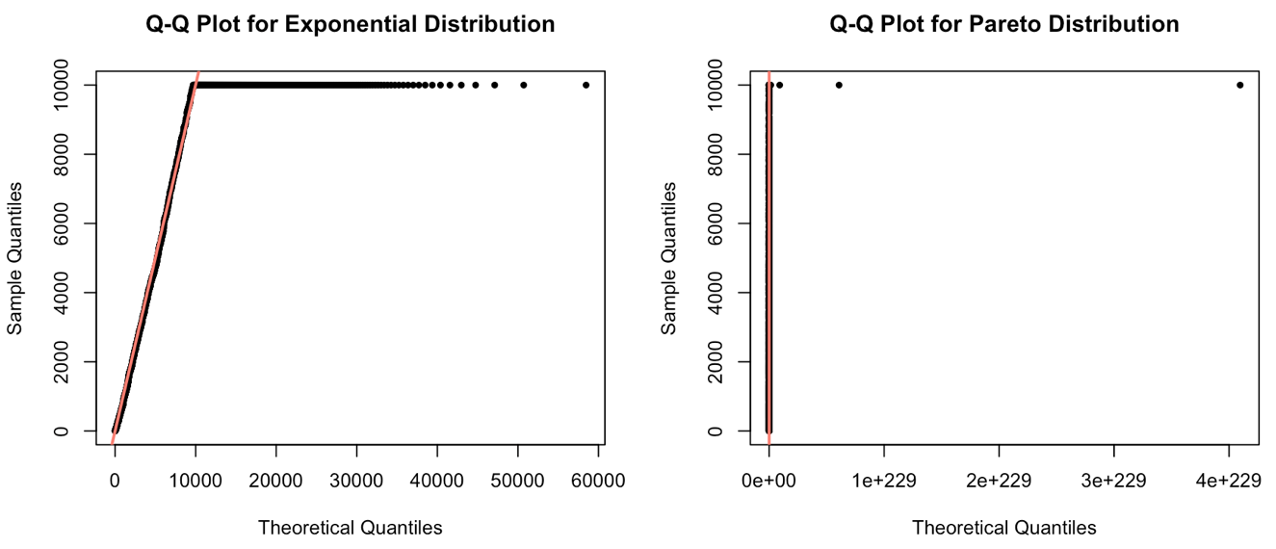

Appendix 6 – Histogram of spread with censoring

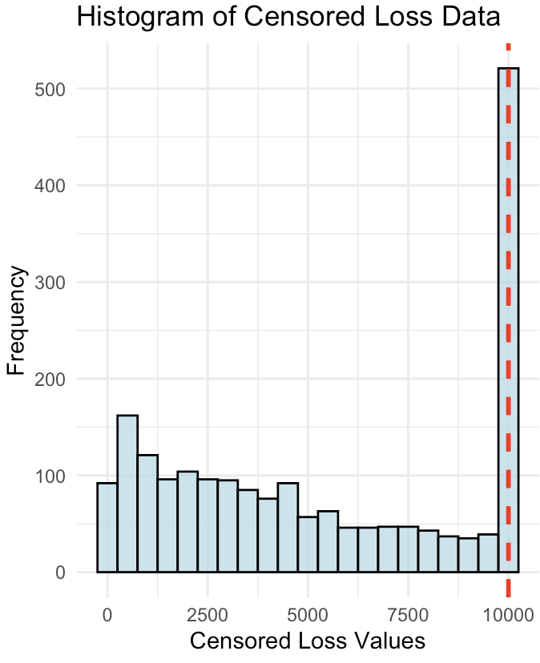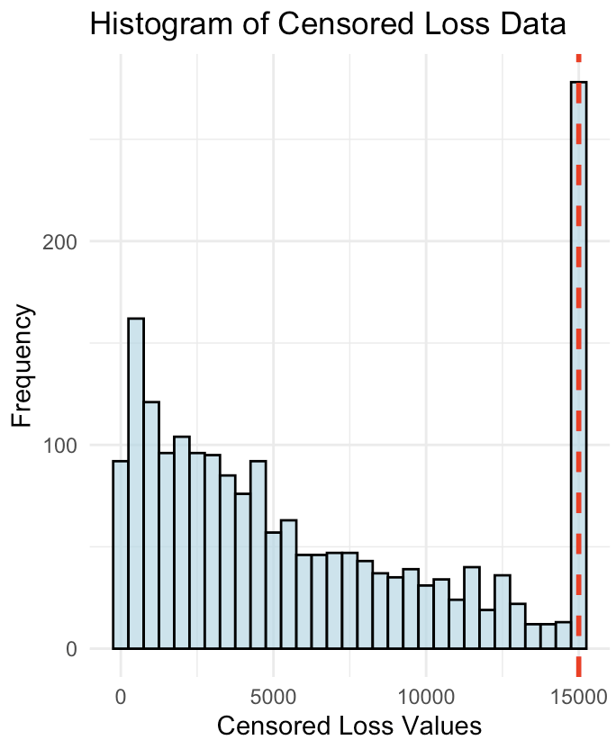

Appendix 7 – AIC and BIC
AIC
$$AIC=-2\hat{l}+2d$$
Our goal is to Achieve a lower AIC value

BIC
$$BIC=-2\hat{l}+2\log\left(n\right)d$$
Similarly, a lower BIC is preferable, and both these tests yield a lower AIC and BIC value, if the log-likelihood is higher.

Appendix 8 – Candidate Model PDF (Taken from ‘orange book’)

Log Normal
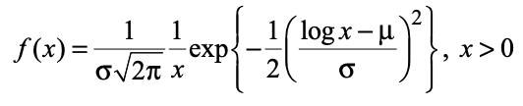

Gamma
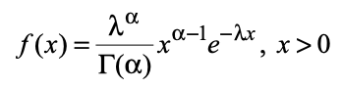

Exponential

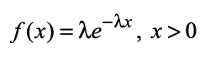

Pareto (2 parameter model)
